Subject: | Language Arts
Title: | Hockey Homonyms
Grade Level: | 6
Purpose: | - Students use hockey words in sentences showing more than one meaning; the different meanings of the word are evident
Curricular  Connections: | - show the relationships among key words associated with topics of study, using a variety of strategies such as thought webs, outlines and lists
Materials: | - Blackboard, smart board, chart paper etc. for instruction  - Printable worksheet (Hockey Homonyms) or lined paper.
Activity: | - Start with a list of 3 words for instruction. For example: goal, score, coach.  - Have students use each of the words in a sentence. Ask if they know another meaning for the word goal. Generate the response that a person can score a goal OR you can have a goal in life.  - Challenge them to discover the two meanings of score. One is a noun and one is a verb. Do the same with coach.  - As a class, students generate a list of 5 more words related to hockey that have more than one meaning. Some examples would be: skate, coach, shot, referee, snack(s), drink(s)  - Students write sentences showing the different meanings of each word. OR Students use a word map to record words that have more than one meaning. Example: The word score is in the middle. The word map shows 3 sentences in separate bubbles: The score is tied. Did you see him score? The coach will score their skating ability.
Extension: | - Have two characters talking to each other, each using a different meaning for the same word. For example:  “Your right skate is untied, and I think you’re going to trip on the lace!”  “Oh, I’d better skate to the bench and tie it tighter.”
Assessment: | - Teacher observes students while they write sentences, providing feedback and assistance where needed.  - Assess students’ work for understanding of homonyms.

Hockey Homonyms
Name:

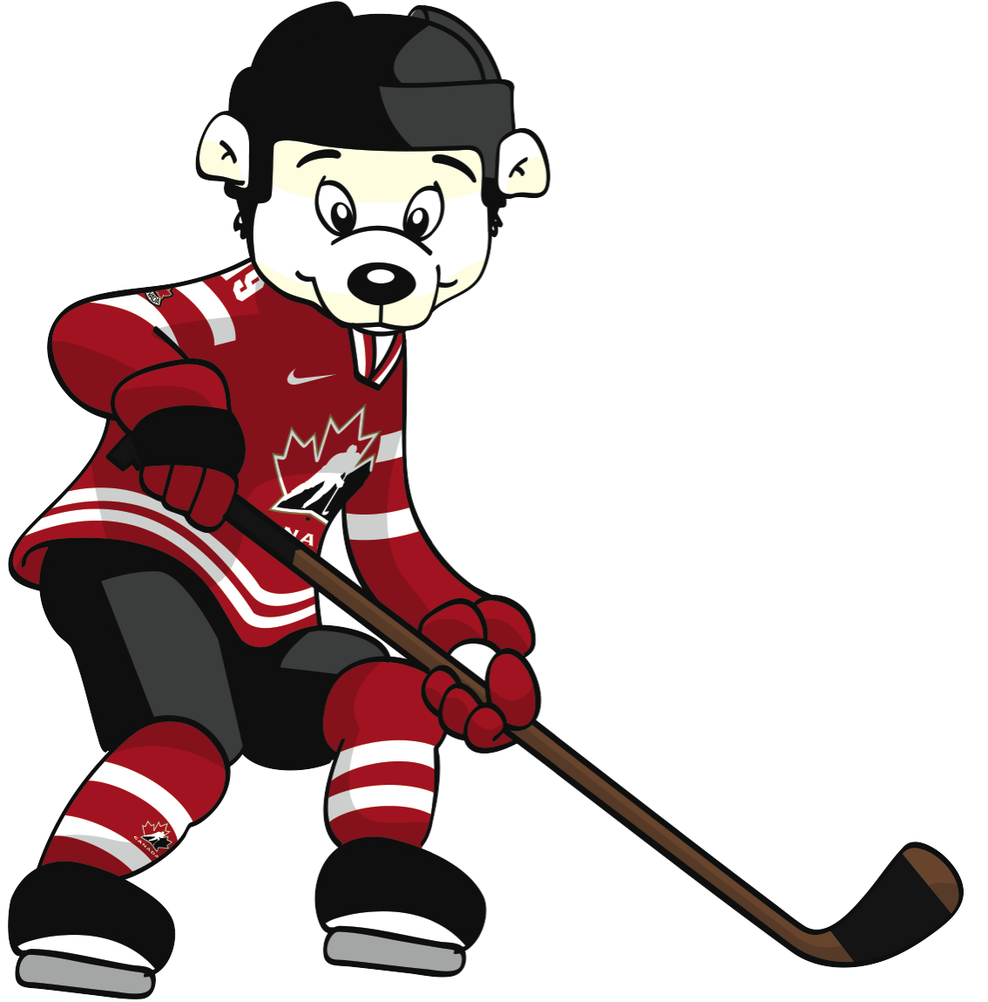
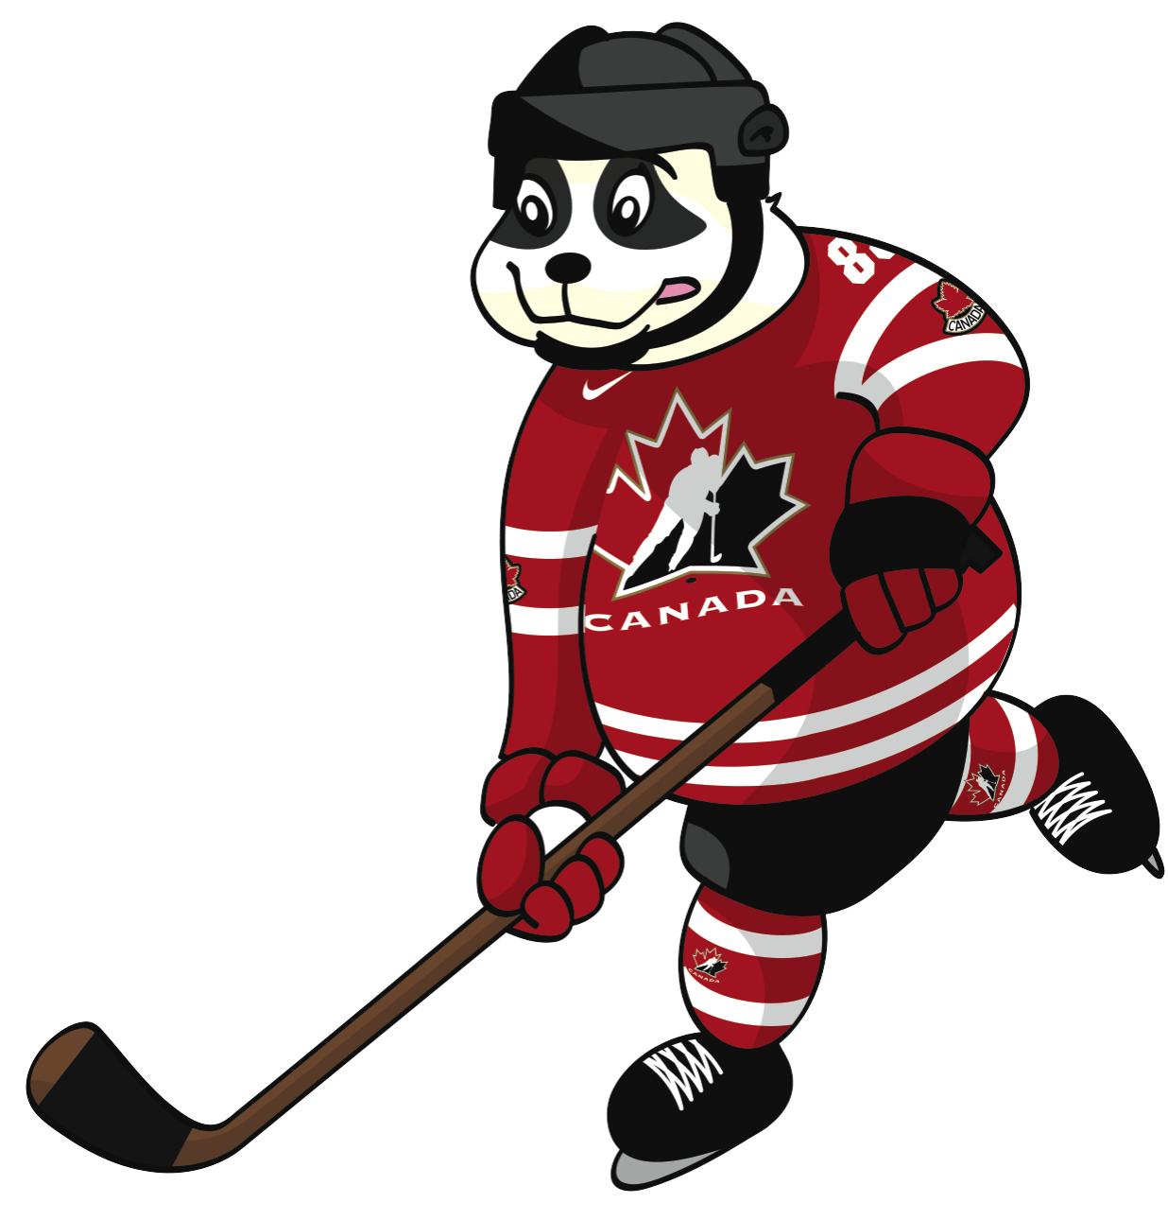

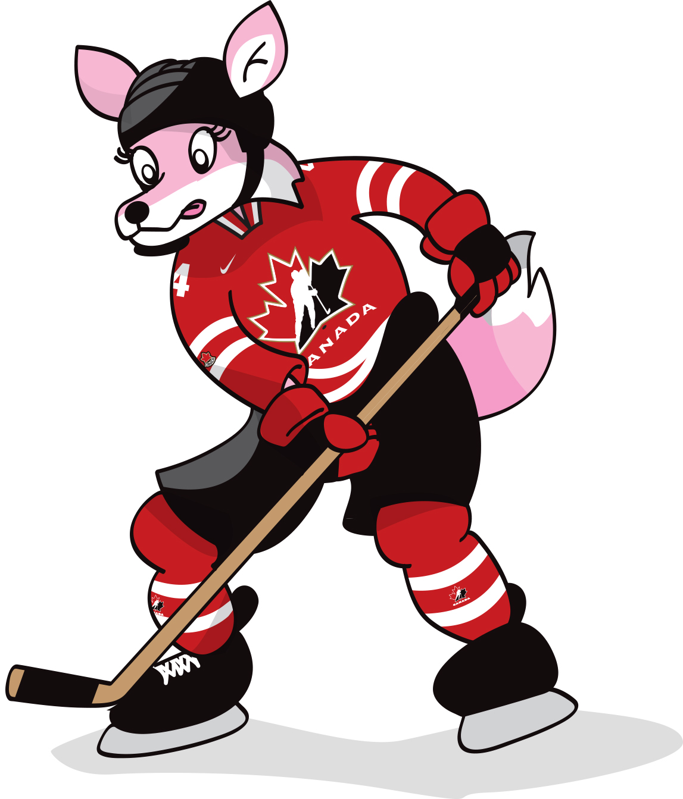
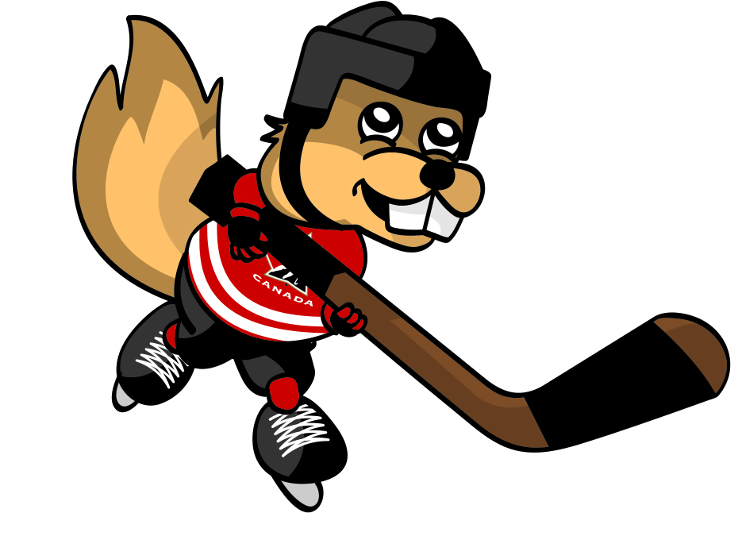
Hockey Homonyms
Name:

