Subject: | Math
Title: | Basic Facts Hockey Puzzle – Fractions
Grade Level: | 6
Purpose: | - Students match the improper fractions to the related mixed number to discover the name of a Hockey Canada player.
Curricular  Connections: | - Relate improper fractions to mixed numbers and mixed numbers to improper fractions.
Materials: | - Worksheet – “Basic Facts Hockey Puzzle - Fractions”
Activity: | - Review mixed and improper fractions with class.  - Distribute worksheet.  - Read directions to students and check for understanding.  - Students complete worksheet by finding the improper fraction that relates to the mixed number and filling in the capital letters to spell the name of a hockey player.
Extension: | Students create their own fraction conversion worksheet with a classmate’s name as the answer. Choose a friend to solve the equations.
Assessment: | Student is able to:  - Understand the relationship between the whole number and the fraction.  - Demonstrate an understanding of the relationship between mixed and improper fractions.

BASIC FACTS HOCKEY PUZZLE - Fractions
Name:__________________

Use the letter of the related fraction to spell the name of the player.
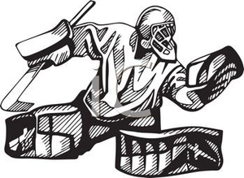 | A. 8 $\frac{4}{5}$ | P. 5$\frac{4}{7}$ | E. 3$\frac{6}{7}$ | N. 5 $\frac{3}{11}$
 | Y. 5 $\frac{6}{7}$ | U. 3$\frac{4}{5}$ | T. 9$\frac{4}{11}$ | R. 6$\frac{7}{9}$
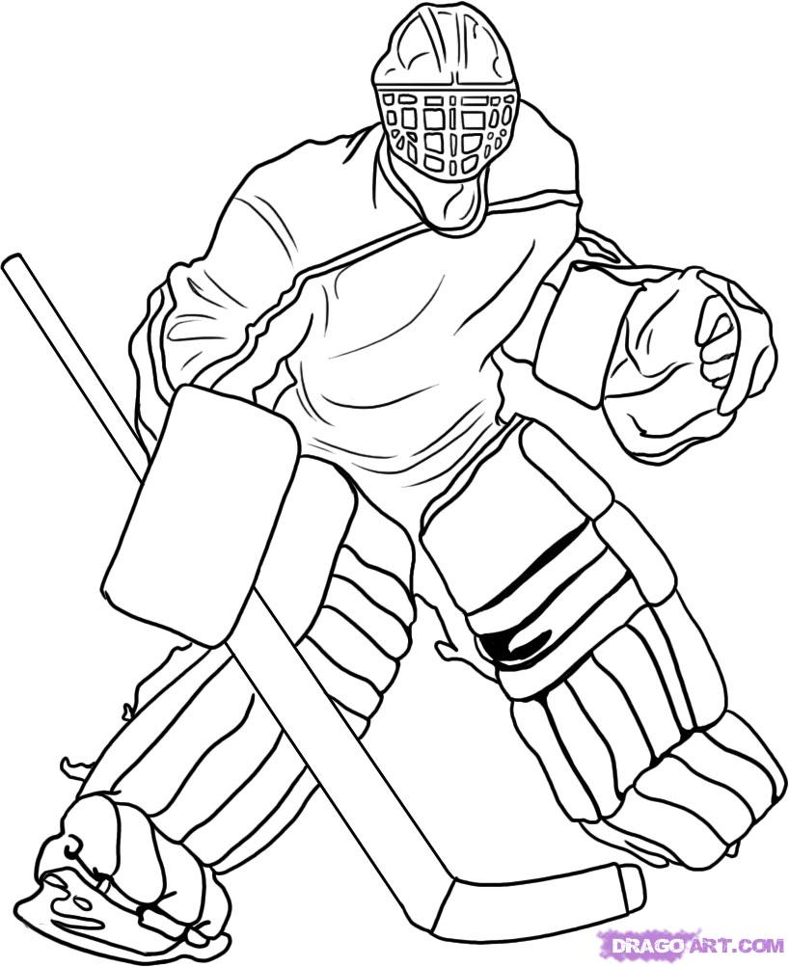 | P. 7$\frac{4}{7}$ | I. 3$\frac{5}{8}$ | L. 5 $\frac{7}{8}$ | E. 3$\frac{2}{5}$
 | O. 3$\frac{3}{4}$ | G. 4 $\frac{3}{10}$ | C. 7$\frac{3}{5}$ | M. 4$\frac{6}{13}$
 | R. 5$\frac{1}{3}$ | C. 2$\frac{5}{9}$ | B. 4$\frac{2}{7}$ | D. 2$\frac{6}{7}$
This hockey hero is a goalie who was named MVP in 2007 when he played in the World Juniors and helped Canada win a gold medal in the 2014 Sochi Winter Olympics.

$\frac{23}{9}$ $\frac{44}{5}$ $\frac{61}{9}$ $\frac{17}{5}$ $\frac{41}{7}$ $\frac{53}{7}$ $\frac{16}{3}$ $\frac{29}{8}$ $\frac{38}{5}$ $\frac{27}{7}$

