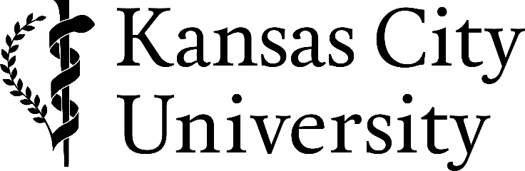

FOR IMMEDIATE RELEASE
Contact: Elizabeth Alex
Public Affairs Director
(816) 654-7032
(816) 304-9498 (cell)
ealex@kcumb.edu

Graduates First Name Graduate’s Last Name Receives a Master of Science in Biomedical Sciences

Kansas City, Mo. (May 8, 2021) – Graduate’s first and last name , was one of 113 students who received a master of science degree from Kansas City University in a commencement ceremony Saturday, May 8, 2021.
Graduate’s last name is the son/daughter of Parent’s Name(s) , graduated from High School and earned a Undergraduate degree degree from Undergraduate College or University .
Graduate’s last name will enter future education or work here.

About Kansas City University
Kansas City University, founded in 1916, is a fully accredited, private not-for-profit health sciences university, with a College of Biosciences and a College of Osteopathic Medicine. The College of Osteopathic Medicine is the eighth largest medical school in the nation, the tenth most affordable of private medical colleges, and the leading producer of physicians for the State of Missouri. The College of Osteopathic Medicine has two campuses strategically located in Kansas City and Joplin, Mo. to address the growing needs of rural and urban populations. The University offers multiple graduate degrees in addition to doctor of osteopathic medicine, including a doctoral program in clinical psychology, a master of arts in bioethics and a master of science in biomedical sciences. Groundbreaking for a College of Dental Medicine in Joplin, Mo. is slated to take place in 2021.

# # #

