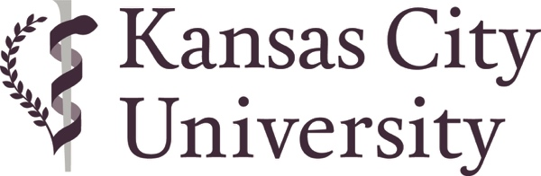

FOR IMMEDIATE RELEASE
Contact: Elizabeth Alex
Sr. Director of PR and Community Outreach
(816) 654-7032
(816) 304-9498 (cell)
ealex@kcumb.edu

Graduates First Name Graduate’s Last Name Receives Medical Degree and Bioethics Degree
KANSAS CITY, Mo. (May 3, 2024) – Graduate’s first and last name , DO, was one of 224 medical students who received the doctor of osteopathic medicine (DO) degree from Kansas City University in Kansas City during a commencement ceremony held on Friday, May 3, 2024.
He/She was also one of 19 KCU graduates who earned a concurrent master of arts in bioethics during the same ceremony.
Dr. Graduate’s last name is the son/daughter of Parent’s Name(s) , graduated from High School and earned a Undergraduate degree degree from Undergraduate College or University .
Dr. Graduate’s last name will complete postdoctoral training in Residency specialty at Residency hospital/medical center in City of residency , State of residency.

About Kansas City University
Kansas City University, founded in 1916, is a fully accredited, private not-for-profit health sciences university with Colleges of Osteopathic Medicine, Biosciences and a College of Dental Medicine. The College of Osteopathic Medicine is the fifth largest medical school in the U.S., the ninth most impactful medical school for primary care for the nation, the tenth most affordable of private medical colleges, and the leading producer of physicians for the State of Missouri. The College of Osteopathic Medicine has two sites strategically located on the University’s campuses in Kansas City and Joplin, Missouri, to address the growing needs of both urban and rural populations. The University offers multiple graduate degrees; a doctor of osteopathic medicine; a doctor of psychology in clinical psychology; a master of arts in bioethics; a master of science in the biomedical sciences; a master of business administration in partnership with Rockhurst University; a new master of public health in partnership with the University of Nebraska Medical Center; and seated the first doctor of dental medicine students in 2023.
# # #

